FIN 525: Investment Strategies

Practice Midterm Exam

Name: ……………………………………………………………………………………...
Instructions:

- Allowed materials: A basic scientific calculator or a financial calculator, and a writing utensil (pencil).
- You are allowed to use self-prepared max. 4-page formula/note sheets for the exam (8.5”x11”). The exam is closed book.
- For the 30 multiple-choice questions, please answer on the provided Scantron form. Mark the bubbles fully and clearly using your pencil. Add your name to the form as well.
- All multiple-choice questions are weighted equally (one point each question).
- You will have 90 minutes to complete this Midterm Exam.
- The ASU Academic Integrity Policy will be strictly observed.
________________________________________________________________________

1. A T-bill quote sheet has 90-day T-bill quotes with a 4.92 bid and a 4.86 ask. If the bill has a $10,000 face value an investor could buy this bill for
A. $10,000.00
B. $9,878.50
C. $9,877.00
D. $9,880.16
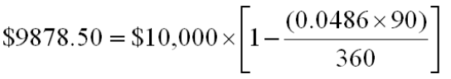

2. The capital market line
I) is a special case of the capital allocation line.
II) represents the opportunity set of a passive investment strategy.
III) has the one-month T-Bill rate as its intercept.
IV) uses a broad index of common stocks as its risky portfolio.
A. | I, III, and IV
B. | II, III, and IV
C. | III and IV
D. | I, II, and III
E. | I, II, III, and IV
The capital market line is the capital allocation line based on the one-month T-Bill rate and a broad index of common stocks. It applies to an investor pursuing a passive management strategy.

3. You invest $10,000 in a complete portfolio. The complete portfolio is composed of a risky asset with an expected rate of return of 15% and a standard deviation of 21% and a treasury bill with a rate of return of 5%. How much money should be invested in the risky asset to form a portfolio with an expected return of 11%?
A. $6,000
B. $4,000
C. $7,000
D. $3,000
15x + 5(1 - x) = 11; x = 60%; 0.60(10,000) = $6,000
4. The _______ decision should take precedence over the _____ decision.
A. asset allocation, stock selection
B. bond selection, mutual fund selection
C. stock selection, asset allocation
D. stock selection, mutual fund selection

5. The optimal risky portfolio can be identified by finding ____________.
I. the minimum variance point on the efficient frontier
II. the maximum return point on the efficient frontier the minimum variance point on the efficient frontier
III. the tangency point of the capital market line and the efficient frontier
IV. the line with the steepest slope that connects the risk free rate to the efficient frontier
A. I and II only
B. II and III only
C. III and IV only
D. I and IV only

6. A portfolio is composed of two stocks, A and B. Stock A has a standard deviation of return of 24% while stock B has a standard deviation of return of 18%. Stock A comprises 60% of the portfolio while stock B comprises 40% of the portfolio. If the variance of return on the portfolio is .0380, the correlation coefficient between the returns on A and B is _________.
A. 0.583
B. 0.225
C. 0.327
D. 0.128
0.0380 = (.6²)(.24²) + (.4²)(.18²) + 2(.6)(.4)(.24)(.18) ρ; ρ = 0.5839.

7. An investor can design a risky portfolio based on two stocks, A and B. The standard deviation of return on stock A is 20% while the standard deviation on stock B is 15%. The correlation coefficient between the return on A and B is 0%. The standard deviation of return on the minimum variance portfolio is _________.
A. 0%
B. 6%
C. 12%
D. 17%
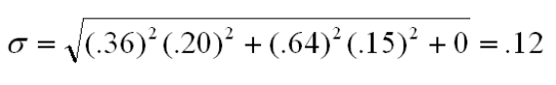

8. Semitool Corp has an expected excess return of 6% for next year. However for every unexpected 1% change in the market, Semitool's return responds by a factor of 1.2. Suppose it turns out the economy and the stock market do better than expected by 1.5% and Semitool's products experience more rapid growth than anticipated, pushing up the stock price by another 1%. Based on this information what was Semitool's actual excess return?
A. 7.00%
B. 8.50%
C. 8.80%
D. 9.25%
6% + (1.5%)(1.2) + 1% = 8.8%

9. Decreasing the number of stocks in a portfolio from 50 to 10 would likely _________________________.
A. increase the systematic risk of the portfolio
B. increase the unsystematic risk of the portfolio
C. increase the return of the portfolio
D. decrease the variation in returns the investor faces in any one year

10. In a simple CAPM world which of the following statements is/are correct?
I. All investors will choose to hold the market portfolio, which includes all risky assets in the world
II. Investors' complete portfolio will vary depending on their risk aversion
III. The return per unit of risk will be identical for all individual assets
IV. The market portfolio will be on the efficient frontier and it will be the optimal risky portfolio
A. I, II and III only
B. II, III and IV only
C. I, III and IV only
D. I, II, III and IV

11. If enough investors decide to purchase stocks they are likely to drive up stock prices thereby causing _____________ and ___________.
A. expected returns to fall; risk premiums to fall
B. expected returns to rise; risk premiums to fall
C. expected returns to rise; risk premiums to rise
D. expected returns to fall; risk premiums to rise

12. You have a $50,000 portfolio consisting of Intel, GE and Con Edison. You put $20,000 in Intel, $12,000 in GE and the rest in Con Edison. Intel, GE and Con Edison have betas of 1.3, 1.0 and 0.8 respectively. What is your portfolio beta?
A. 1.048
B. 1.033
C. 1.000
D. 1.037

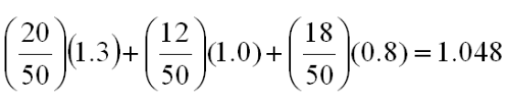

13. Consider the capital asset pricing model. The market degree of risk aversion, A, is 3. The variance of return on the market portfolio is .0225. If the risk-free rate of return is 4%, the expected return on the market portfolio is _________.
A. 6.75%
B. 9.0%
C. 10.75%
D. 12.0%
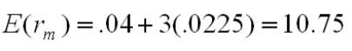

14. Security A has an expected rate of return of 12% and a beta of 1.10. The market expected rate of return is 8% and the risk-free rate is 5%. The alpha of the stock is _________.
A. -1.7%
B. 3.7%
C. 5.5%
D. 8.7%
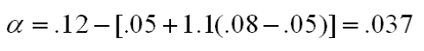

15. Consider the following two stocks, A and B. Stock A has an expected return of 10% and a beta of 1.20. Stock B has an expected return of 14% and a beta of 1.80. The expected market rate of return is 9% and the risk-free rate is 5%. Security __________ would be considered a good buy because _________.
A. A, it offers an expected excess return of 0.2%
B. A, it offers an expected excess return of 2.2%
C. B, it offers an expected excess return of 1.8%
D. B, it offers an expected return of 2.4%
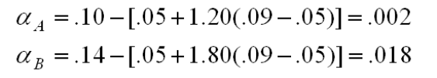

16. According to the CAPM, investors are compensated for all but which of the following?
A. Expected inflation
B. Systematic risk
C. Time value of money
D. Residual risk

17. One of the main problems with the arbitrage pricing theory is __________.
A. its use of several factors instead of a single market index to explain the risk-return relationship
B. the introduction of non-systematic risk as a key factor in the risk-return relationship
C. that the APT requires an even larger number of unrealistic assumptions than the CAPM
D. the model fails to identify the key macroeconomic variables in the risk-return relationship

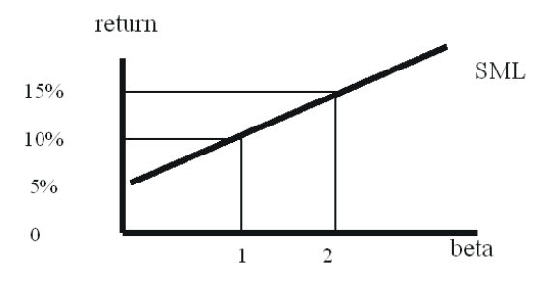
18. See the above graph. What is the beta for a portfolio with an expected return of 12.5%?
A. 0
B. 1
C. 1.5
D. 2
Since 10% return corresponds to beta = 1, and 15% corresponds to beta = 2, 12.5% return will equal to beta (1 + 2)/2 = 1.5
19. You consider buying a share of stock at a price of $25. The stock is expected to pay a dividend of $1.50 next year and your advisory service tells you that you can expect to sell the stock in one year for $28. The stock's beta is 1.1, rf is 6% and E[rm] = 16%. What is the stock's abnormal return?
A. 1%
B. 2%
C. -1%
D. -2%
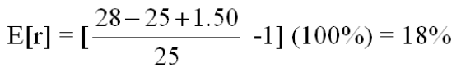
Required return = 6% + (16% - 6%)(1.1) = 17%
Abnormal return = 18% - 17% = 1%

20. The risk premium for exposure to aluminum commodity prices is 4% and the firm has a beta relative to aluminum commodity prices of 0.6. The risk premium for exposure to GDP changes is 6% and the firm has a beta relative to GDP of 1.2. If the risk free rate is 4.0%, what is the expected return on this stock?
A. 10.0%
B. 11.5%
C. 13.6%
D. 14.0%
Return = .04 + 0.6(0.04) + 1.2(.06) = .136

21. You are constructing a scatter plot of excess returns for Stock A versus the market index. If the correlation coefficient between Stock A and the index is -1 you will find that the points of the scatter diagram ______________________ and the line of best fit has a ______________.
A. all fall on the line of best fit; positive slope
B. all fall on the line of best fit; negative slope
C. are widely scattered around the line; positive slope
D. are widely scattered around the line; negative slope
22. If an investor does not diversify their portfolio and instead puts all of their money in one stock, the appropriate measure of security risk for that investor is the ________.
A. stock's standard deviation
B. variance of the market
C. stock's beta
D. covariance with the market index

An investor can design a risky portfolio based on two stocks, A and B. Stock A has an expected return of 18% and a standard deviation of return of 20%. Stock B has an expected return of 14% and a standard deviation of return of 5%. The correlation coefficient between the returns of A and B is 0.50. The risk-free rate of return is 10%.
23. The proportion of the optimal risky portfolio that should be invested in stock A is _________.
A. 0%
B. 40%
C. 60%
D. 100% 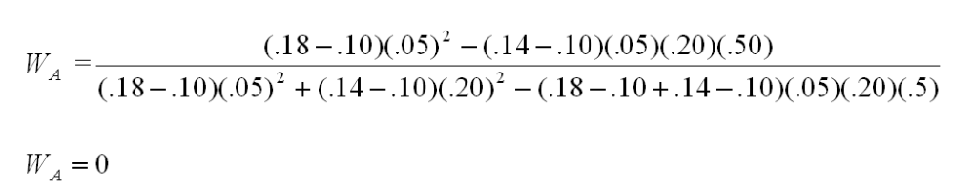

24. Which of the following statements is true regarding time diversification?
I. The standard deviation of the average annual rate of return over several
years will be smaller than the one-year standard deviation.
II. For a longer time horizon, uncertainty compounds over a greater number
of years.
III. Time diversification does not reduce risk.
A. I only
B. II only
C. II and III only
D. I, II and III
E. None of the statements are correct

25. If you want to know the portfolio standard deviation for a three stock portfolio you will have to
A. calculate two covariances and one trivariance
B. calculate only two covariances
C. calculate three covariances
D. average the variances of the individual stocks

26. You are considering adding a new security to your portfolio. In order to decide whether you should add the security you need to know the security's _______.
I. expected return
II. standard deviation
III. correlation with your portfolio
A. I only
B. I and II only
C. I and III only
D. I, II and III

27. What is the standard deviation of a portfolio of two stocks given the following data? Stock A has a standard deviation of 18%. Stock B has a standard deviation of 14%. The portfolio contains 40% of stock A and the correlation coefficient between the two stocks is -.23.
A. 9.7%
B. 12.2%
C. 14.0%
D. 15.6%

28. Research has identified two systematic factors that affect U.S. stock returns. The factors are growth in industrial production and changes in long term interest rates. Industrial production growth is expected to be 3% and long term interest rates are expected to increase by 1%. You are analyzing a stock is that has a beta of 1.2 on the industrial production factor and 0.5 on the interest rate factor. It currently has an expected return of 12%. However, if industrial production actually grows 5% and interest rates drop 2% what is your best guess of the stock's return?
A. 15.9%
B. 12.9%
C. 13.2%
D. 12.0%
E[r_{new}] = 12% + (5% - 3%)(1.2) + (-2% - 1%)(0.5) = 12.9%

29. To build an indifference curve we can first find the utility of a portfolio with 100% in the risk-free asset, then
A. | find the utility of a portfolio with 0% in the risk-free asset.
B. | change the expected return of the portfolio and equate the utility to the standard deviation.
C. | find another utility level with 0% risk.
D. | change the standard deviation of the portfolio and find the expected return the investor would require to maintain the same utility level.
E. | change the risk-free rate and find the utility level that results in the same standard deviation.

This question references the procedure described in the text. The authors describe how to trace out indifference curves using a spreadsheet.

30. Your client, Bo Regard, holds a complete portfolio that consists of a portfolio of risky assets (P) and T-Bills. The information below refers to these assets.
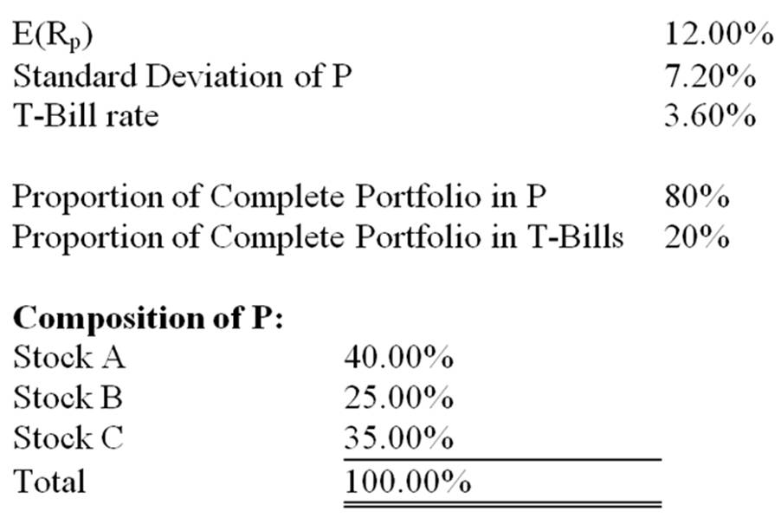
What are the proportions of stocks A, B, and C, respectively, in Bo's complete portfolio?
A. | 40%, 25%, 35%
B. | 8%, 5%, 7%
C. | 32%, 20%, 28%
D. | 16%, 10%, 14%
E. | 20%, 12.5%, 17.5%
Proportion in A = .8 × 40% = 32%; proportion in B = .8 × 25% = 20%; proportion in C = .8 × 35% = 28%.

